[IBM Datacap](https://www.ibm.com/docs/en/datacap/9.1.9?topic=documentation-whats-new-in-datacap-version-919) is a robust data capture solution designed to streamline the transformation of unstructured information into actionable data. It leverages advanced optical character recognition (OCR) technology, machine learning, and natural language processing (NLP) to accurately extract and classify data from a variety of sources, such as scanned documents, emails, and PDFs.

This automation not only enhances data accuracy but also significantly reduces manual processing time, allowing businesses to improve operational efficiency and focus on higher-value tasks. With seamless integration capabilities, IBM Datacap ensures smooth data flow across enterprise systems, making it a critical tool for digital transformation initiatives.

How can generative AI add value to document processing ?

* IBM Datacap faces challenges in handling diverse document formats, maintaining high accuracy in data extraction, and managing complex document layouts.
* Continuous training and updates are required to keep pace with evolving data types, which can be resource-intensive.
* Generative AI can significantly enhance data classification and extraction by providing more accurate and adaptive OCR capabilities.
* It can automatically recognize and adapt to new document formats and layouts, reducing the need for constant manual updates.
* By improving data classification and validation processes, generative AI ensures higher accuracy and efficiency in data capture, adding substantial value to IBM Datacap's functionality.

Prerequisites

To integrate IBM Datacap with Large Language Models ( LLM’s) requires:

* IBM Datacap 9.1.9 with IFIX 5
* Setup to install watsonx_ai actions
* IBM Watsonx.ai account
* Sample Documents to process

Steps

Step 1. Ensure the Datacap 9.1.9 version is upgraded to IFIX005 . If not , download the IFIX005 from fix central and upgrade the current installation .

1. IFIX005 must consist of two executable files **Update.exe** and **UpdateOCR.exe**
2. Run **Update.exe** first and then **UpdateOCR.exe**
3. Once the process if completed download the setup from [here](https://ibm.box.com/s/pu426nf9i6x2sl690dpa6s8ly4cyjvgo) to install **watsonx_ai** actions in IBM Datacap action library
4. Now , open IBM Datacap Studio for APT application to test the installation .

1. In the **Actions Library** , scroll down to see **watsonx_ai** actions listed there . Upon expanding , you should be able to see the actions associated with it .

*If* **watsonx_ai** *is still not visible in Actions library, please double check the version of IBM Datacap and ensure prerequisites have been taken care of* .

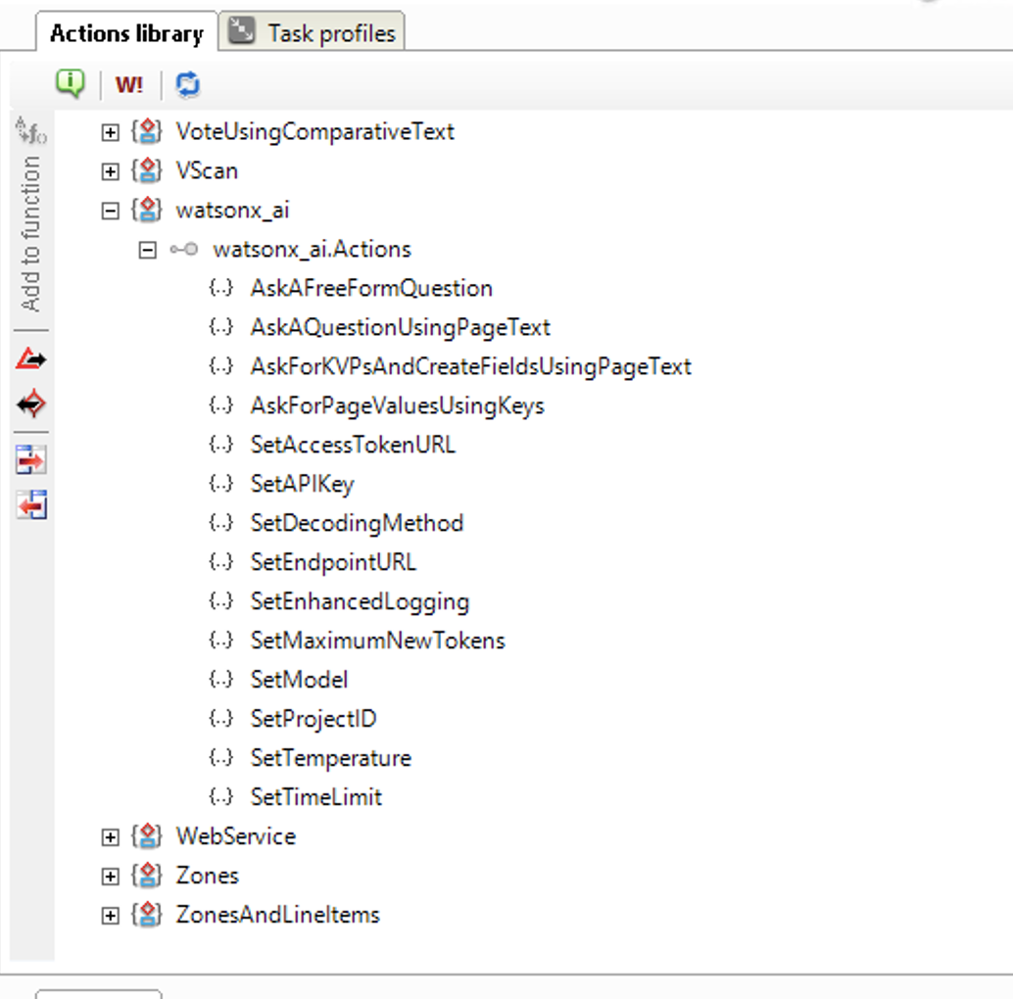

Step 2. Download the sample application **watsonxai**

1. Click here to download the application **watsonxai** from [here](https://ibm.box.com/s/2qvgw64syoz3bss0ra9rp21vm3qfczix)
2. Extract the file and copy the application namely **watsonxai** in C:\Datacap\ folder .

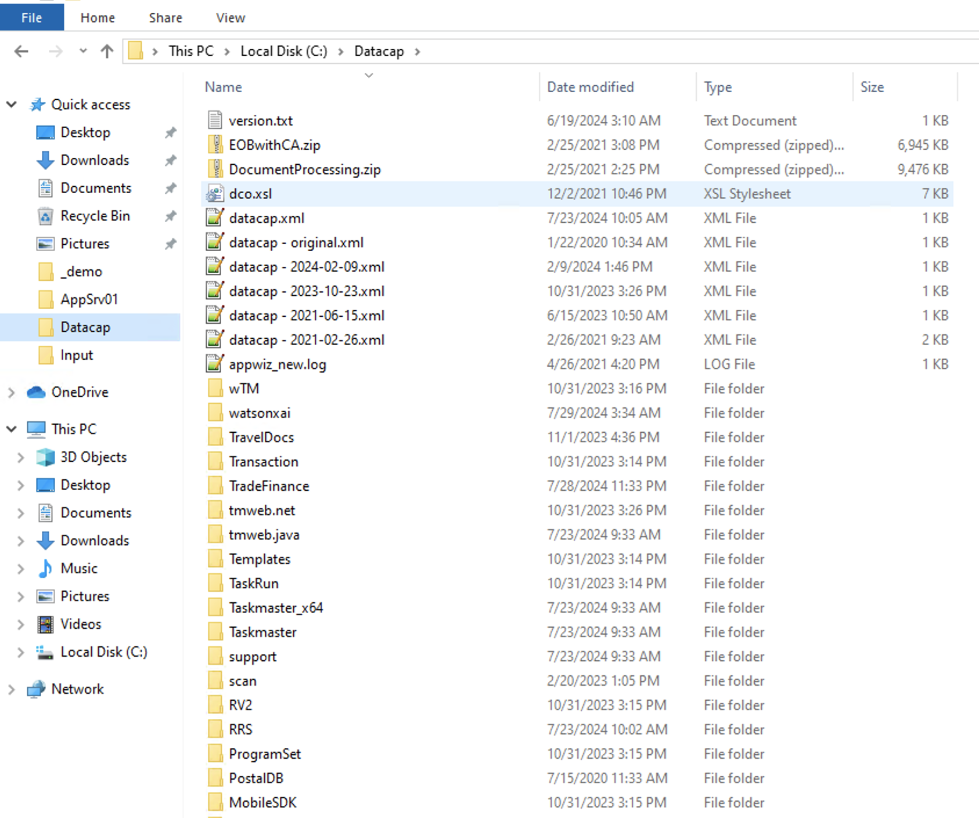

1. In the same folder , open and view **datacap.xml** and add an entry in the xml like the image given below :

1. If the configuration is correct , you should be able to see **watsonxai** application in Datacap Application Manager .

1. Next step would be to open Datacap Studio , select **watsonxai** application and login using admin/admin credentials .

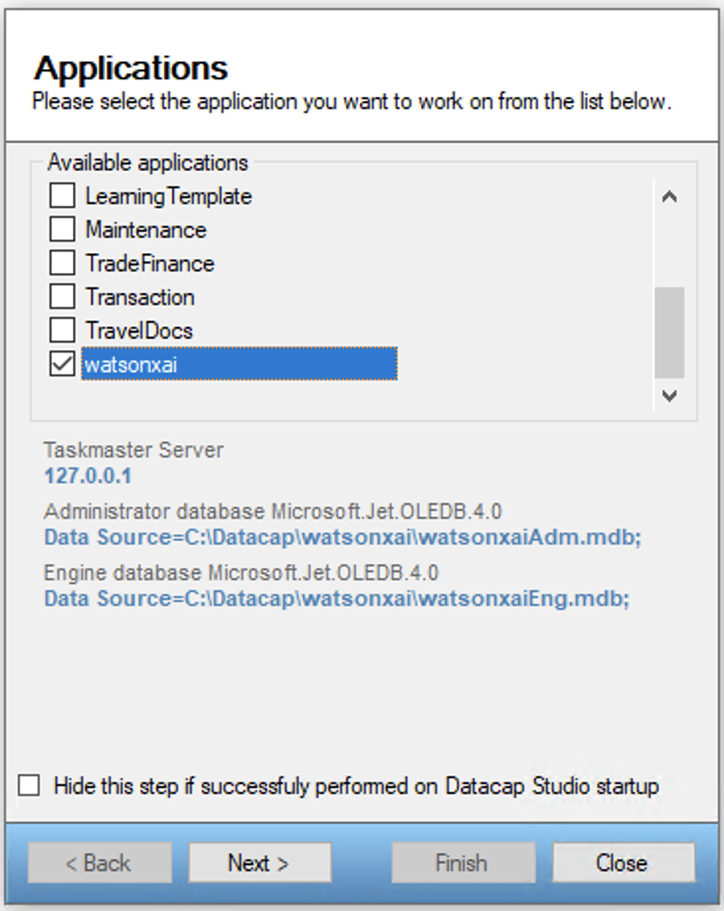

Summary

In this tutorial you learned how to configure watsonx.ai actions into your existing Datacap setup .

Learn more about [building skills](https://www.ibm.com/docs/en/watson-orchestrate?utm_source=ibm_developer&utm_content=in_content_link&utm_id=tutorials_awb-custom-skills-openapi-watsonx-orchestrate&topic=building-skills&cm_sp=ibmdev-_-developer-tutorials-_-ibmcom), [creating OpenAPI files](https://www.ibm.com/docs/en/watson-orchestrate?utm_source=ibm_developer&utm_content=in_content_link&utm_id=tutorials_awb-custom-skills-openapi-watsonx-orchestrate&topic=skills-creating-openapi-specifications&cm_sp=ibmdev-_-developer-tutorials-_-ibmcom), and [guidelines for designing skills](https://www.ibm.com/docs/en/watson-orchestrate?utm_source=ibm_developer&utm_content=in_content_link&utm_id=tutorials_awb-custom-skills-openapi-watsonx-orchestrate&topic=skills-skill-design-content-guidelines&cm_sp=ibmdev-_-developer-tutorials-_-ibmcom) in the watsonx Orchestrate docs.